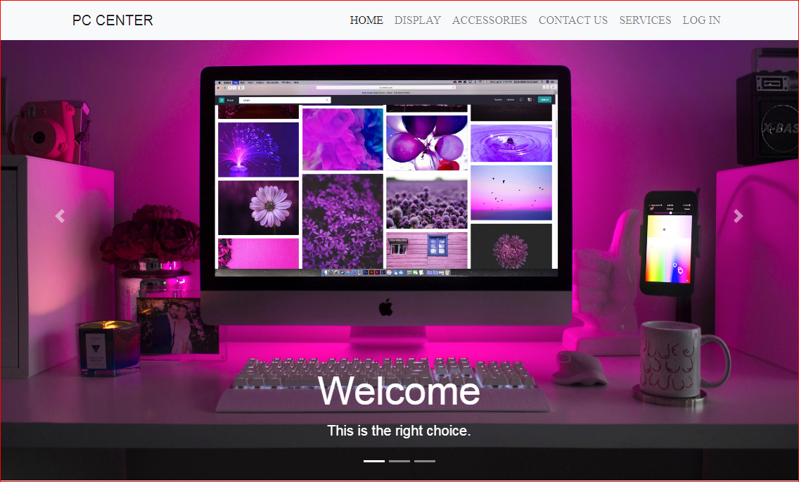

# E - Project Developer guide

# Faculty : Sir Tufail Khan

# Batch Co-ordinator : miss Kiran Nadeem

# Batch Code : 1901B1

**PC CENTER**

**Muhammad Husnain**

[**Hasnainm206@gmail.com**](mailto:Hasnainm206@gmail.com)

**Student Id :** **1166828**

**Daniyal Khan**

[**Dk720820@gmail.com**](mailto:Dk720820@gmail.com)

**Student Id :** **1168447**

**Muhammad Moin**

[**Moinsahab718@gmail.com**](mailto:Moinsahab718@gmail.com)

**Student Id : 1166953**

**Project Group Members**

Muhammad Husnain

[**Hasnainm206@gmail.com**](mailto:Hasnainm206@gmail.com)

Student Id :

Daniyal Khan

[**Dk720820@gmail.com**](mailto:Dk720820@gmail.com)

Student Id :

Muhammad Moin

[**Moinsahab718@gmail.com**](mailto:Moinsahab718@gmail.com)

**Student Id : 1166953**

**Members**





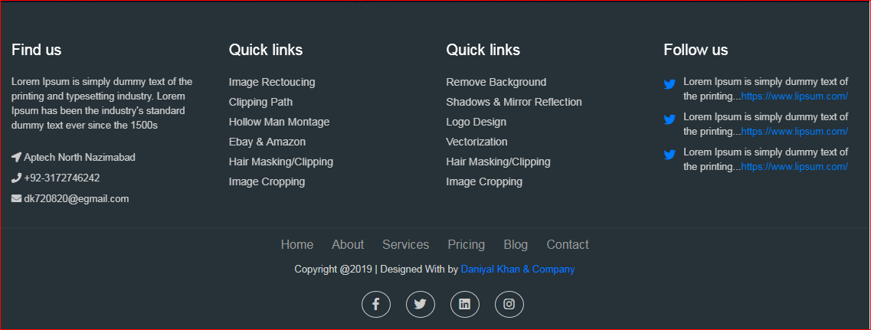





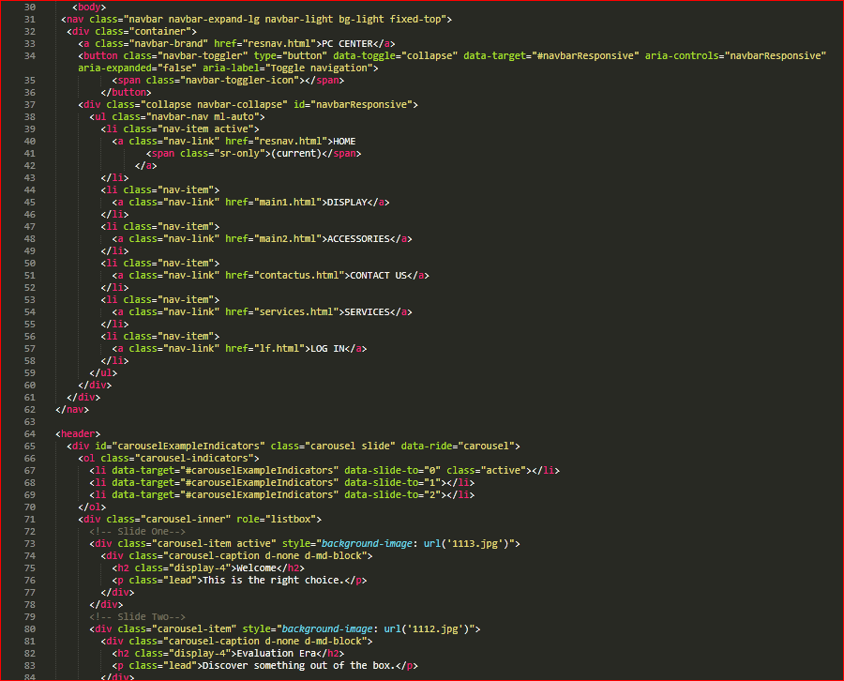



**

DISPLAY

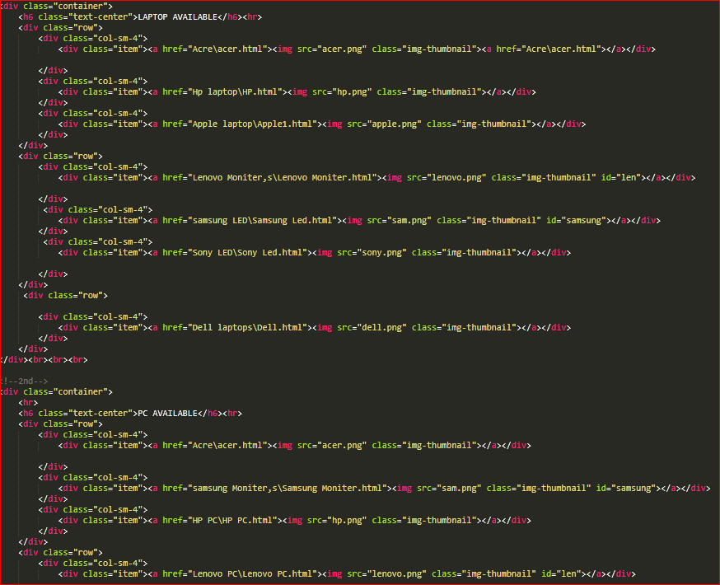





Accessories

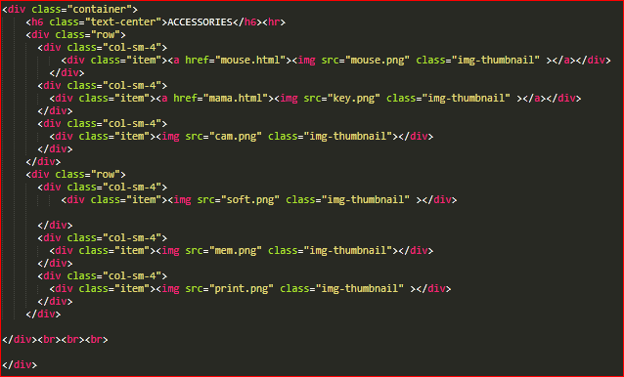



**



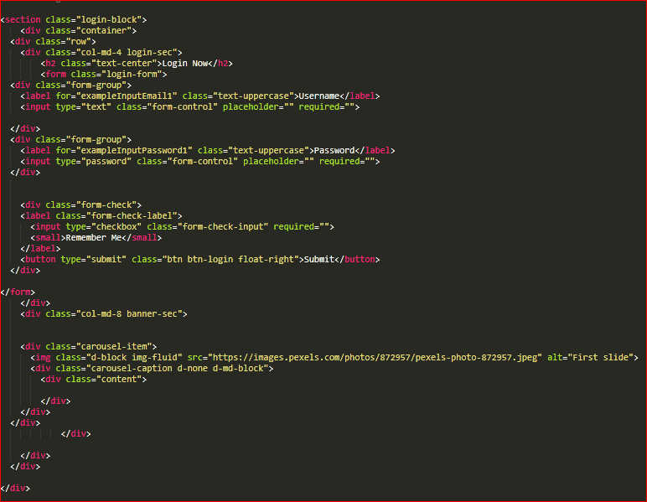

Registration form

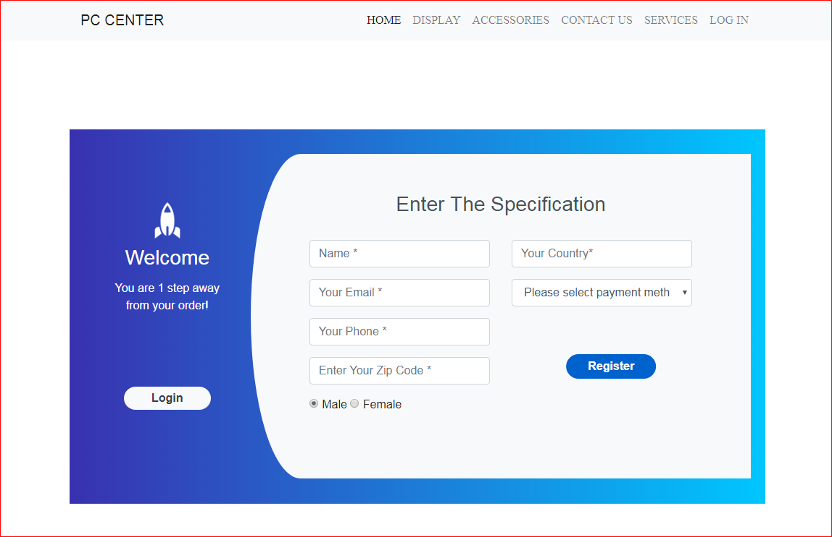



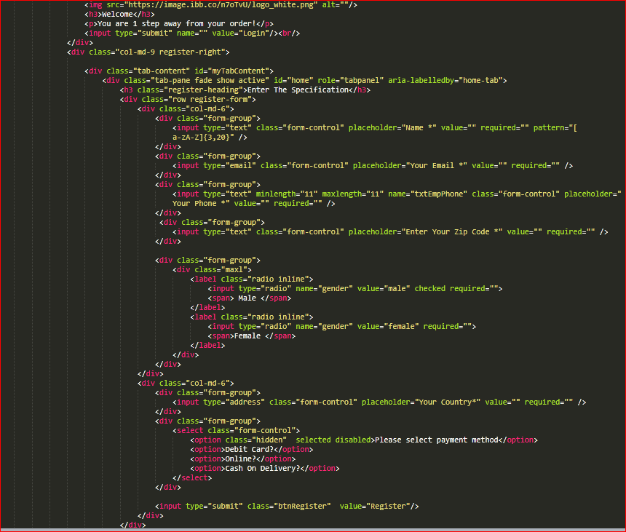

Registration form



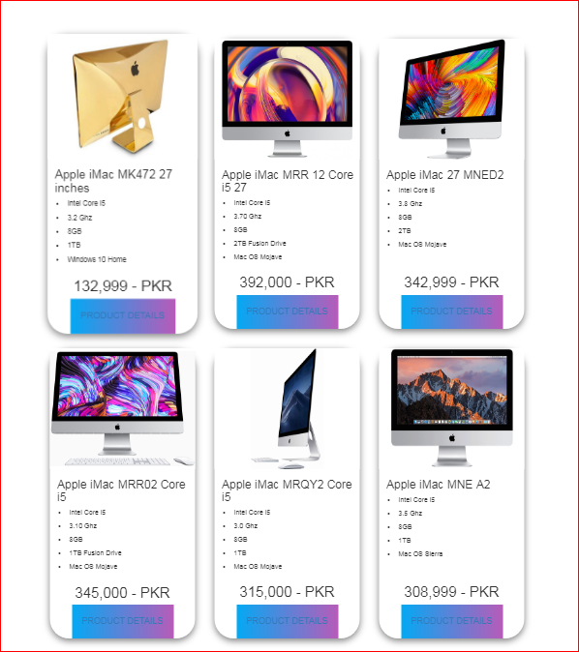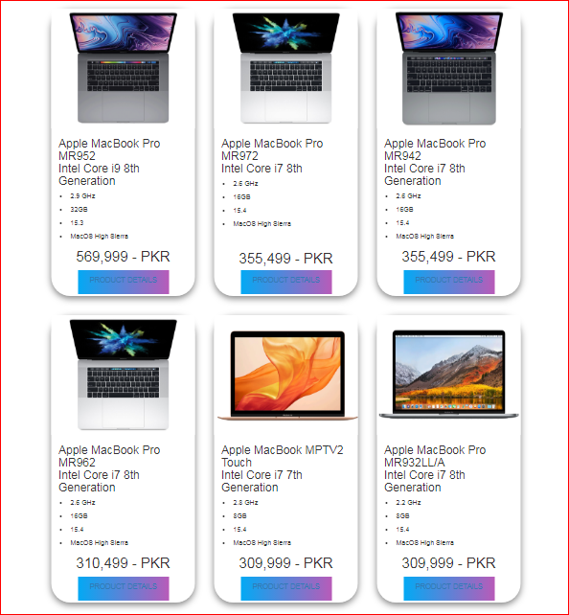

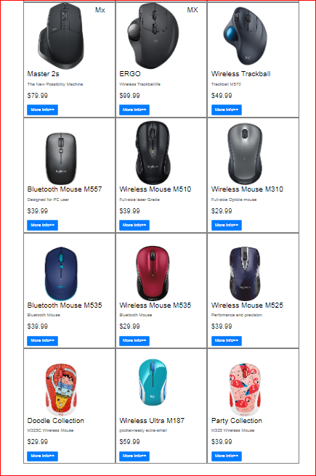



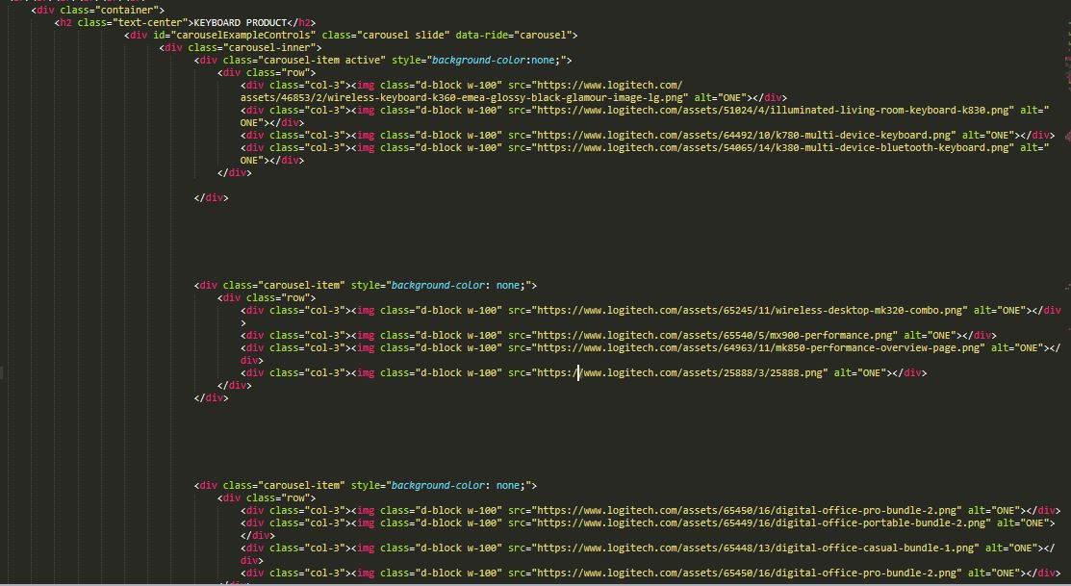

Cvsd***PRODUCT DETAILS***

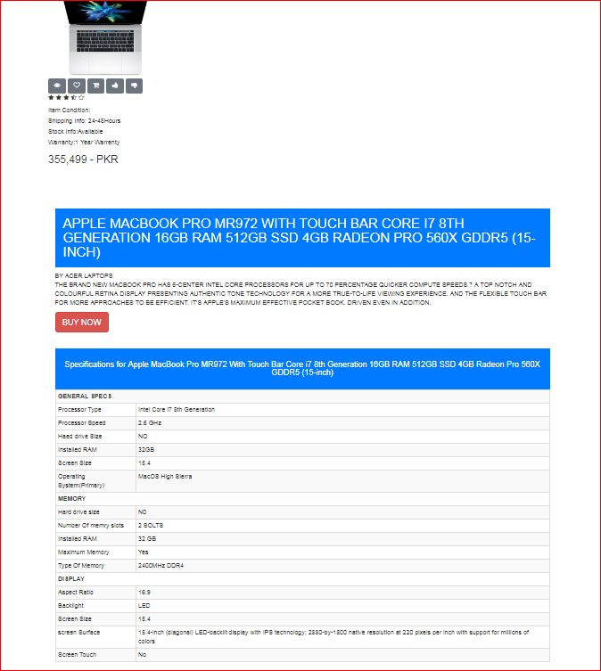

**

**

***PRODUCT DETAILS***

